**PF ASSIGNMENT – 11**

**QUESTION#1**

Write a program to implement the exchange or swap the values of 3 variables{a,b,c}. To implement this, you need tomwrite a function called swaped().

CODE:

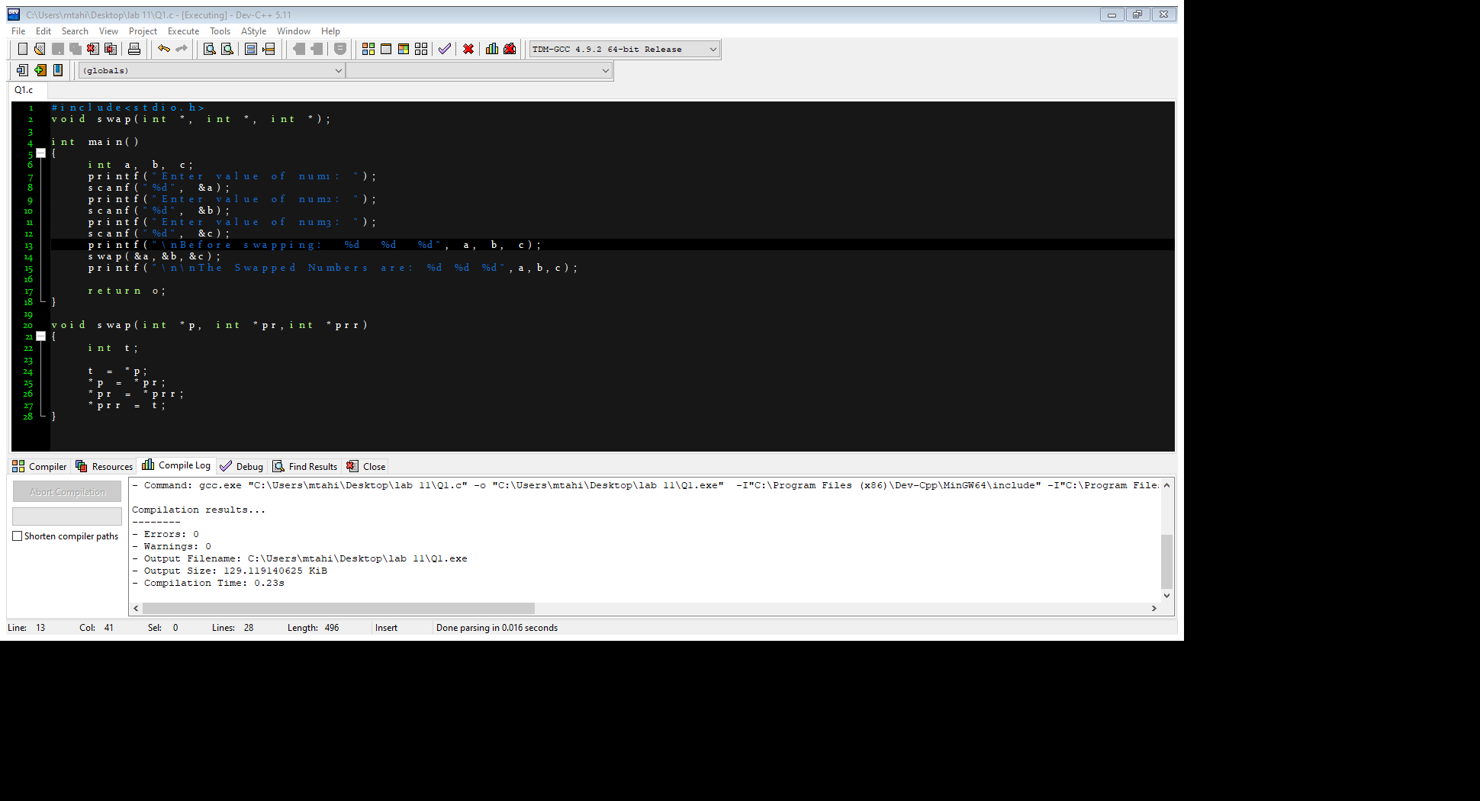

OUTPUT:

**QUESTION#2**

Write a program that calculates the sum of all the elements in array using pointers.

CODE:

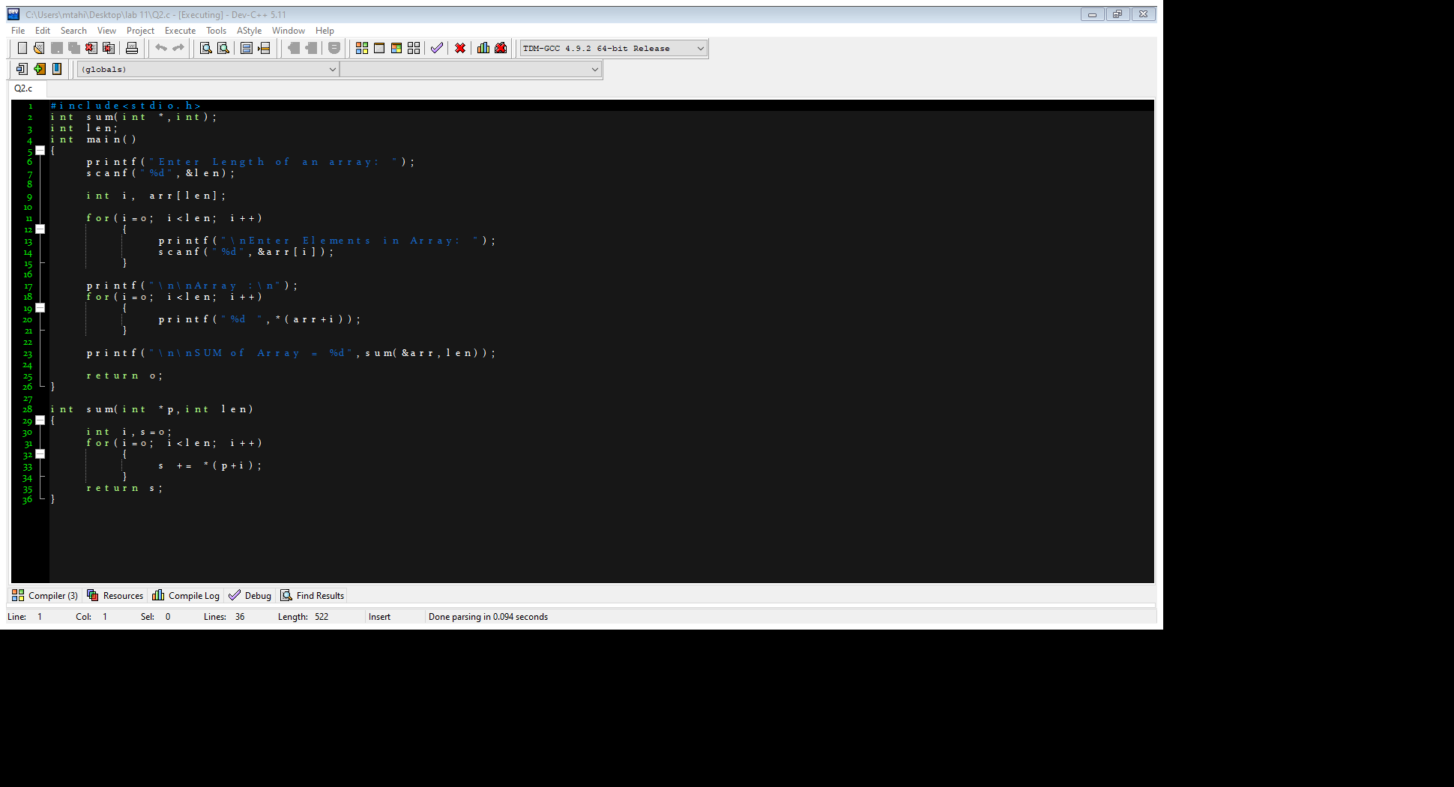

OUTPUT:

**QUESTION#3**

Write a program to find the min and max from an array using pointers.

CODE:

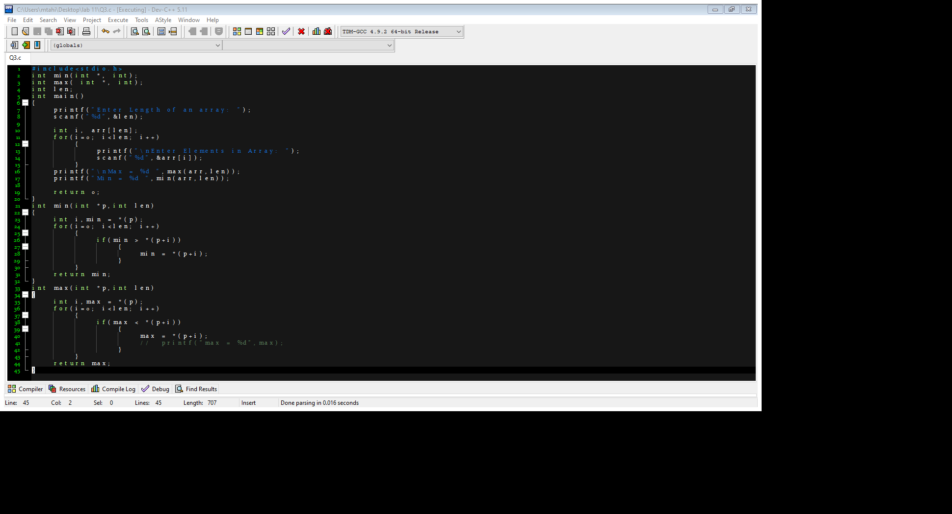

OUTPUT:

**QUESTION#4**

Write a program that implements the function (Wordcount).

CODE:

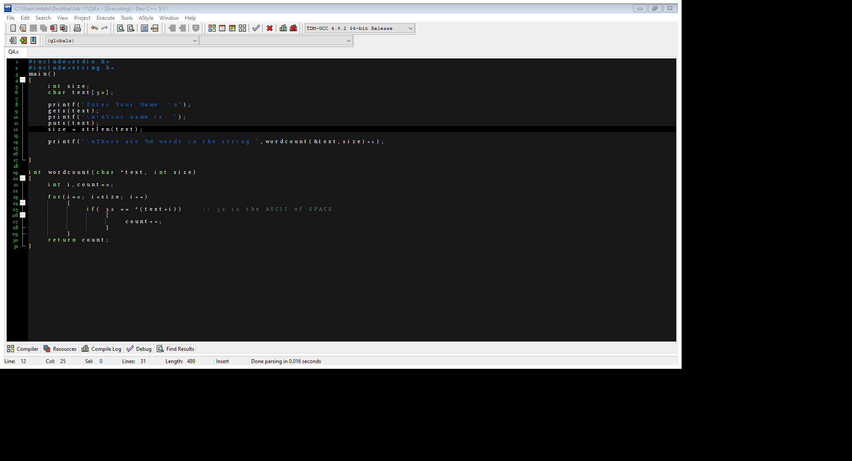

OUTPUT:

**QUESTION#5**

Write a program to create a calculator using array of pointer to function.

CODE:

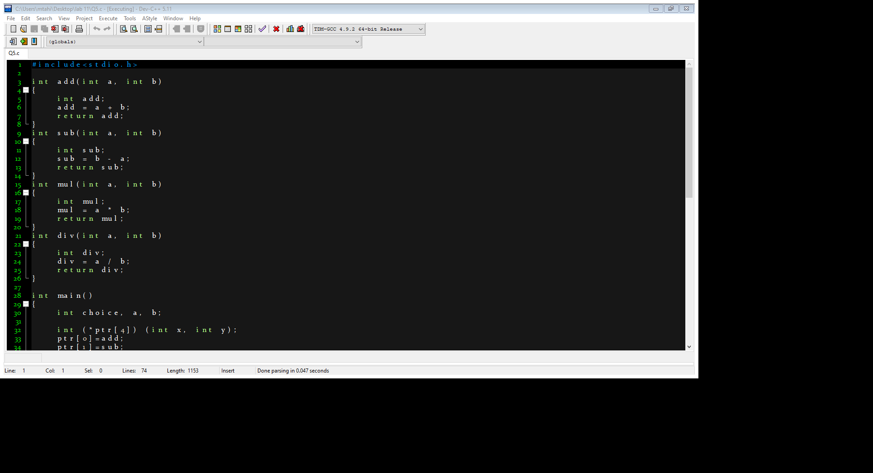

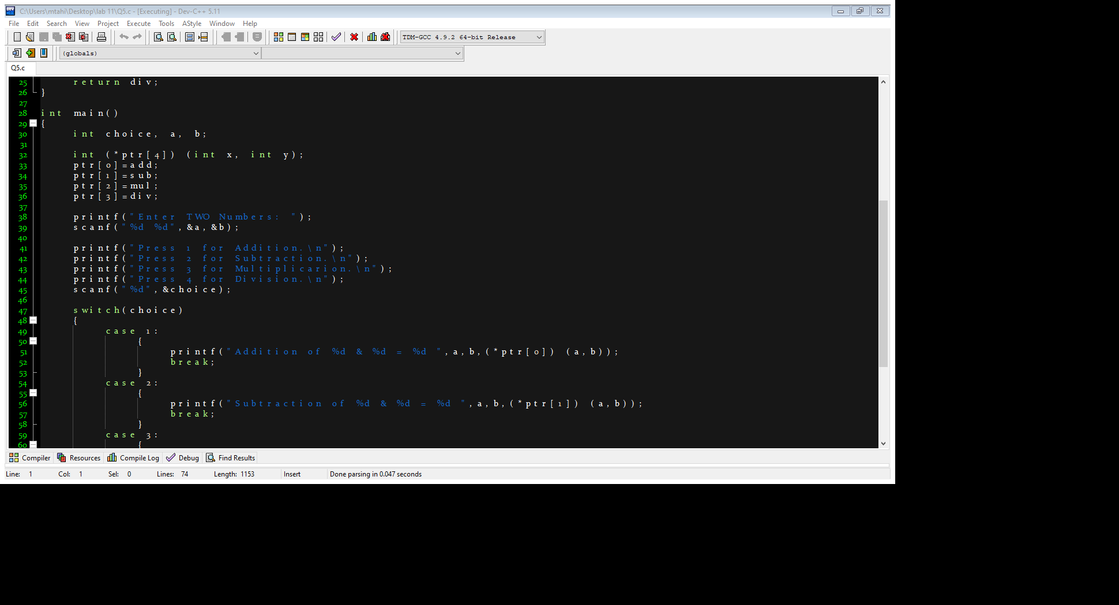

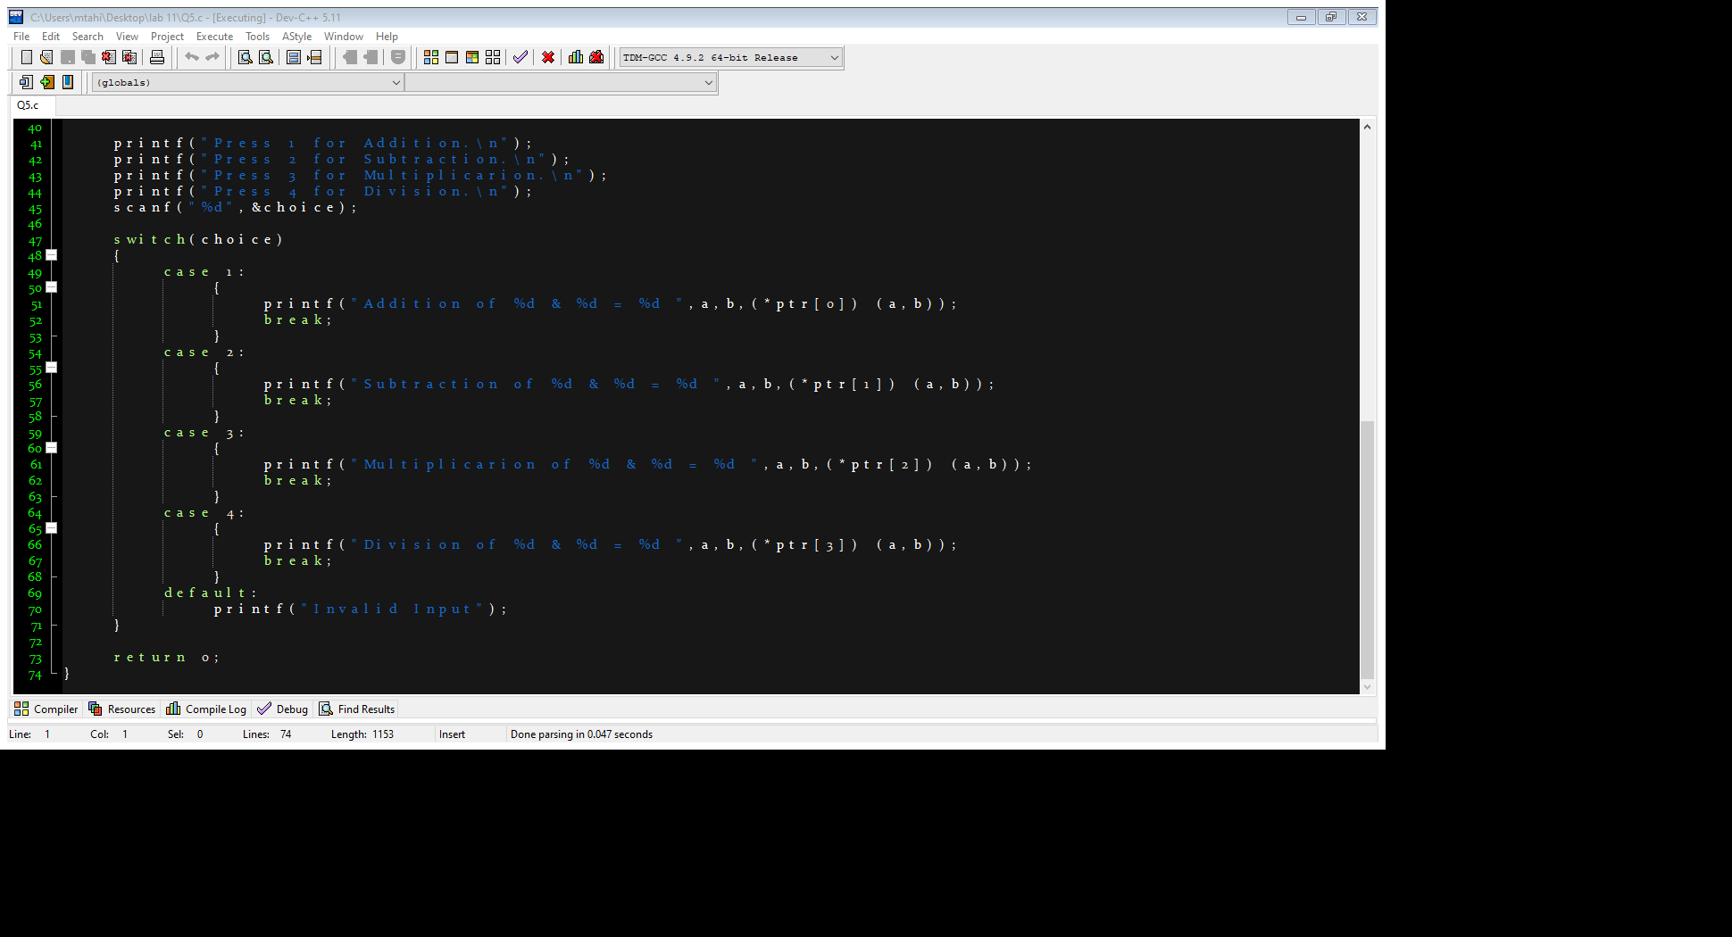

OUTPUT:

**QUESTION#6**

Write a program to find middle element of the array using pointers.

CODE:

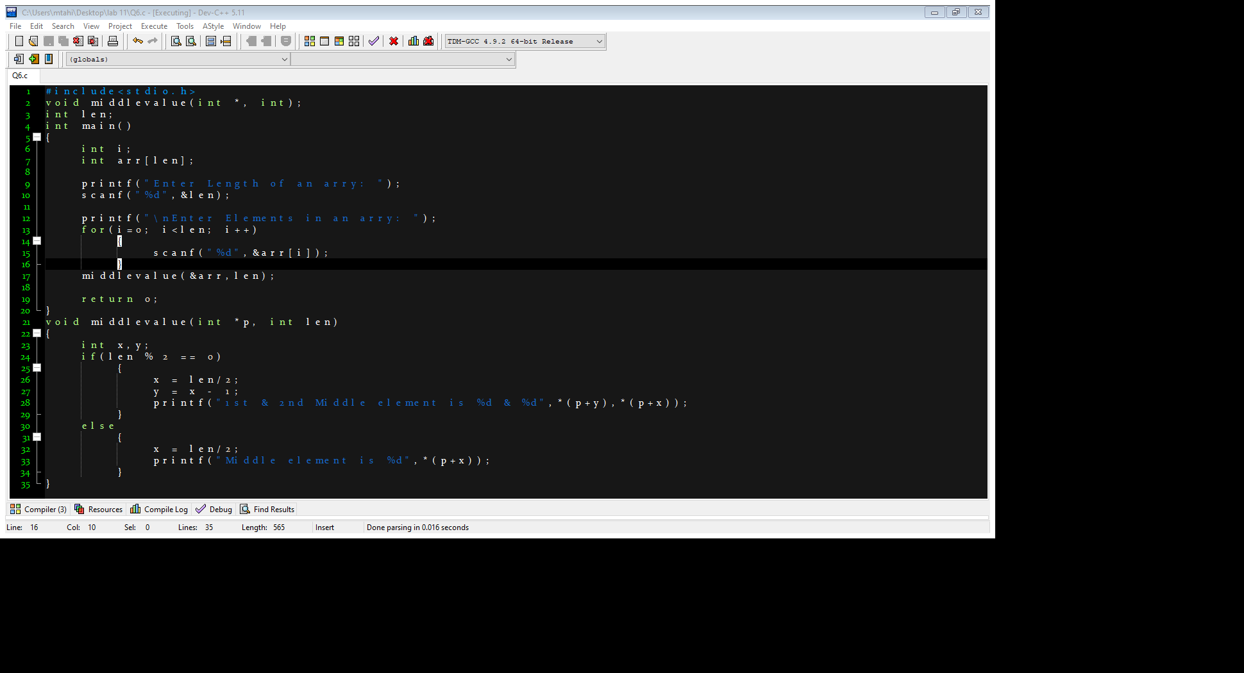

OUTPUT:

**QUESTION#7**

You need to implement the following 2 struct.

struct Student {}; struct Register {};

Student contains attribute Student, FirstName, Last Name, cell no, email.

Register contains attribute Course Id, Course Name.

CODE:

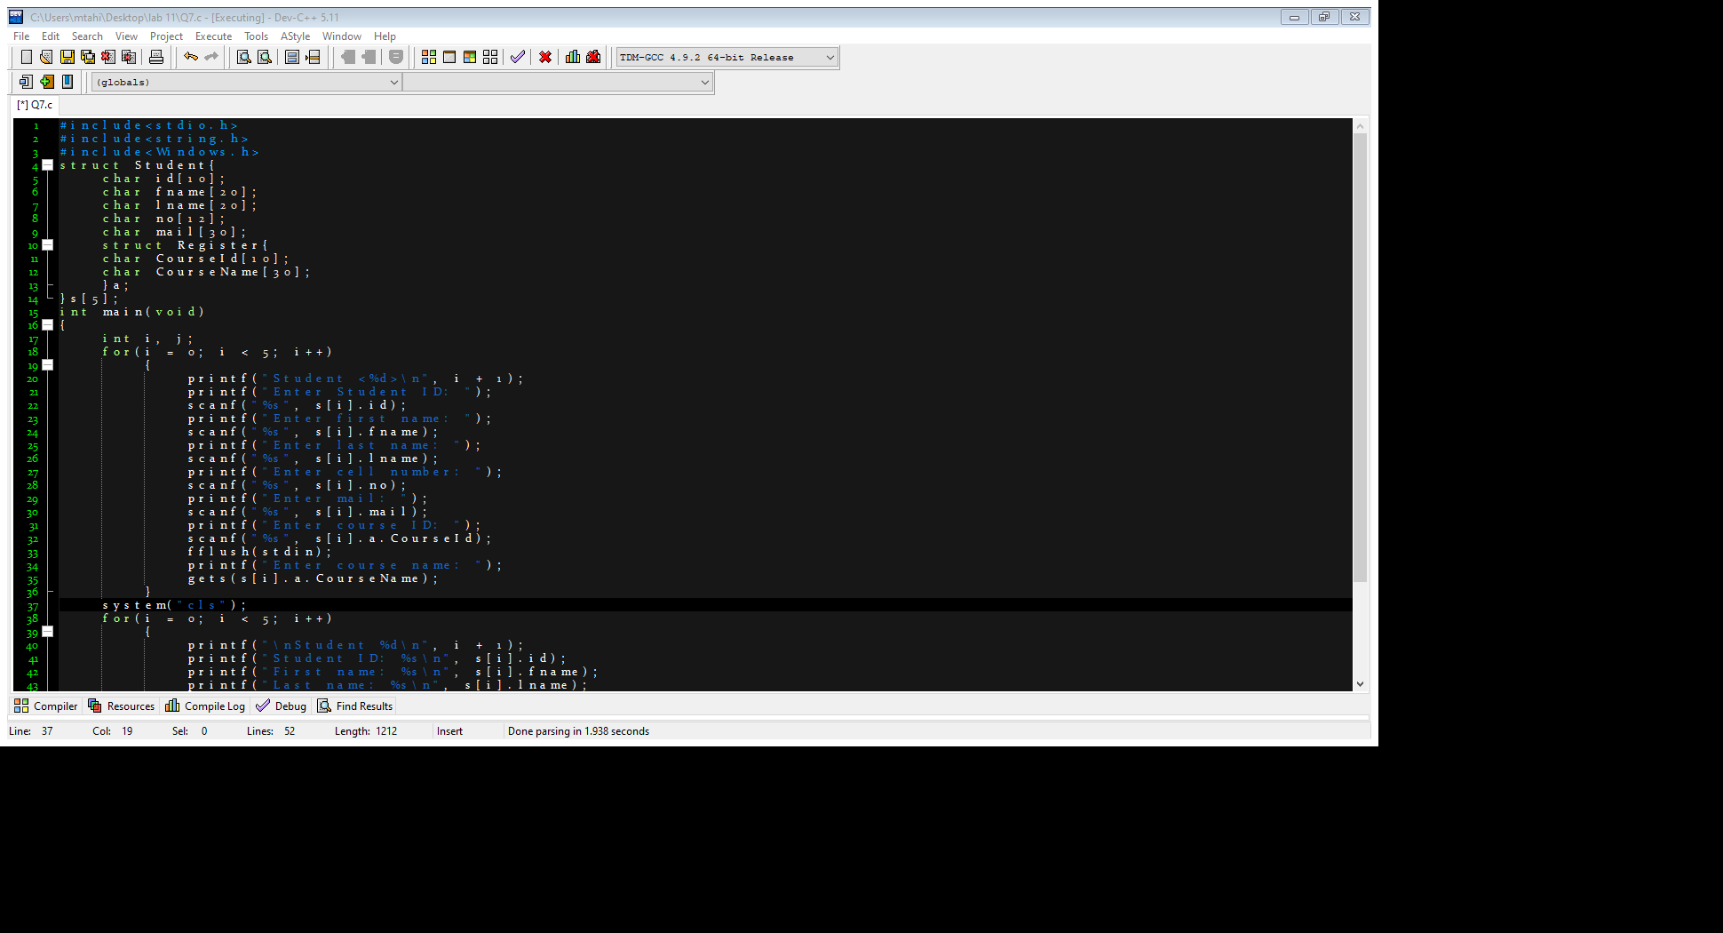

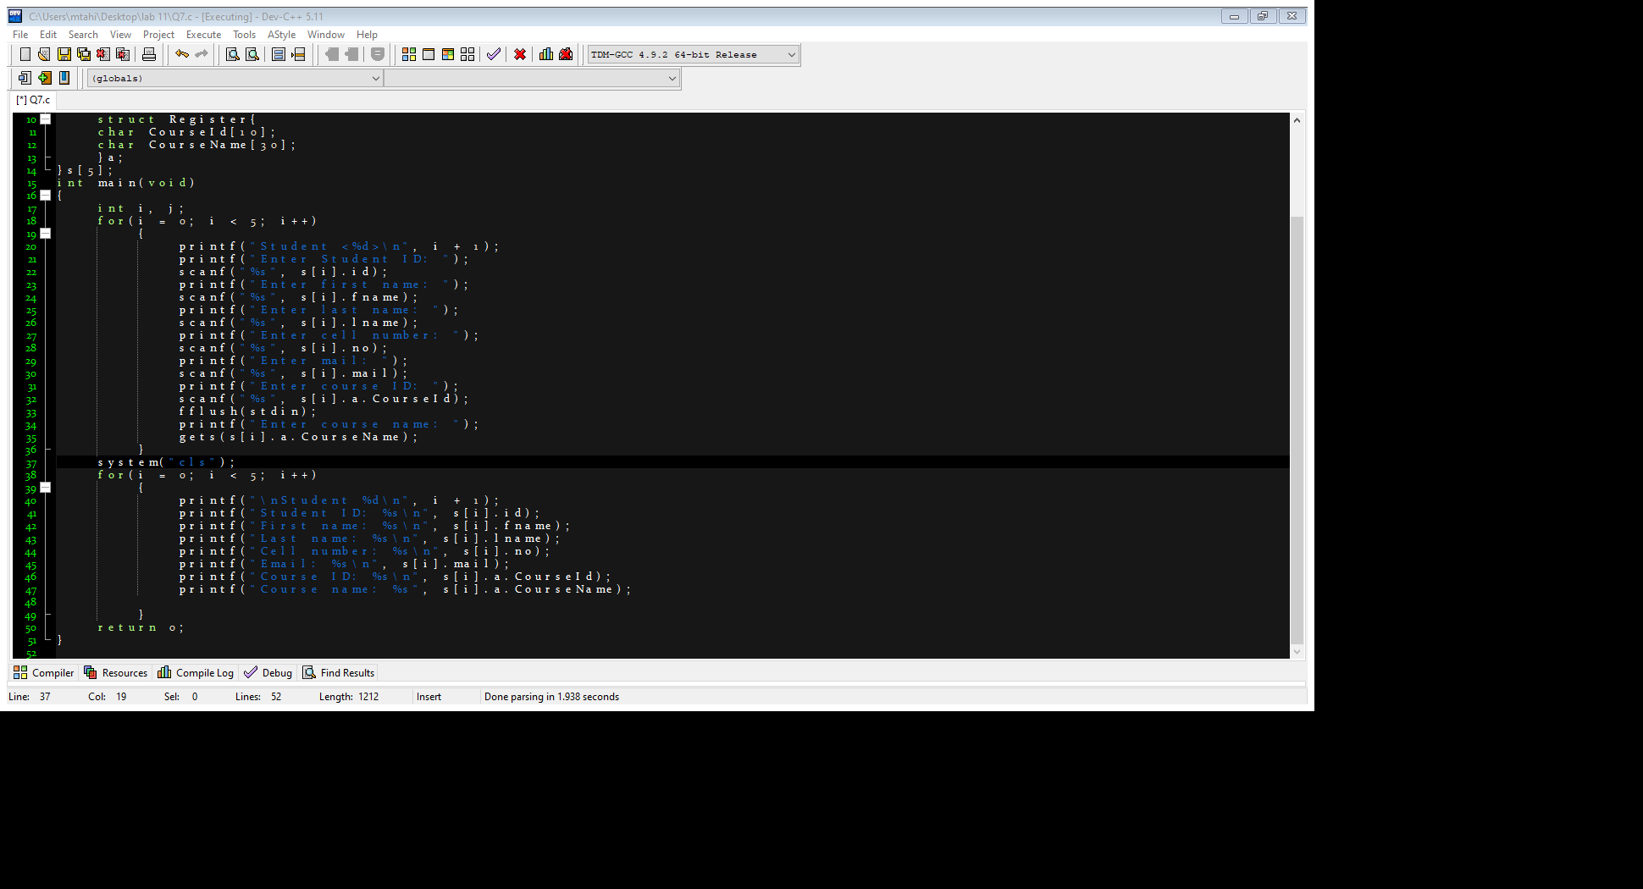

OUTPUT:

NOTE:

Attached Screen Shot is after executing CLEAR SCREEN command

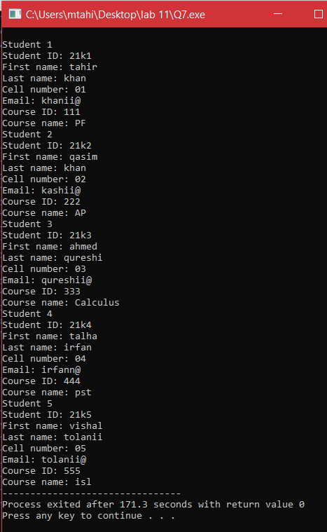

**QUESTION#8**

Using question 7, Now you need to inherit the Register struct in Student struct. It means that student struct holds the variable of Register structs variable. After that you need to take input for 5 students and then print them

[Hint: Declare array of struct Student std [5]; for 5 students]

CODE:

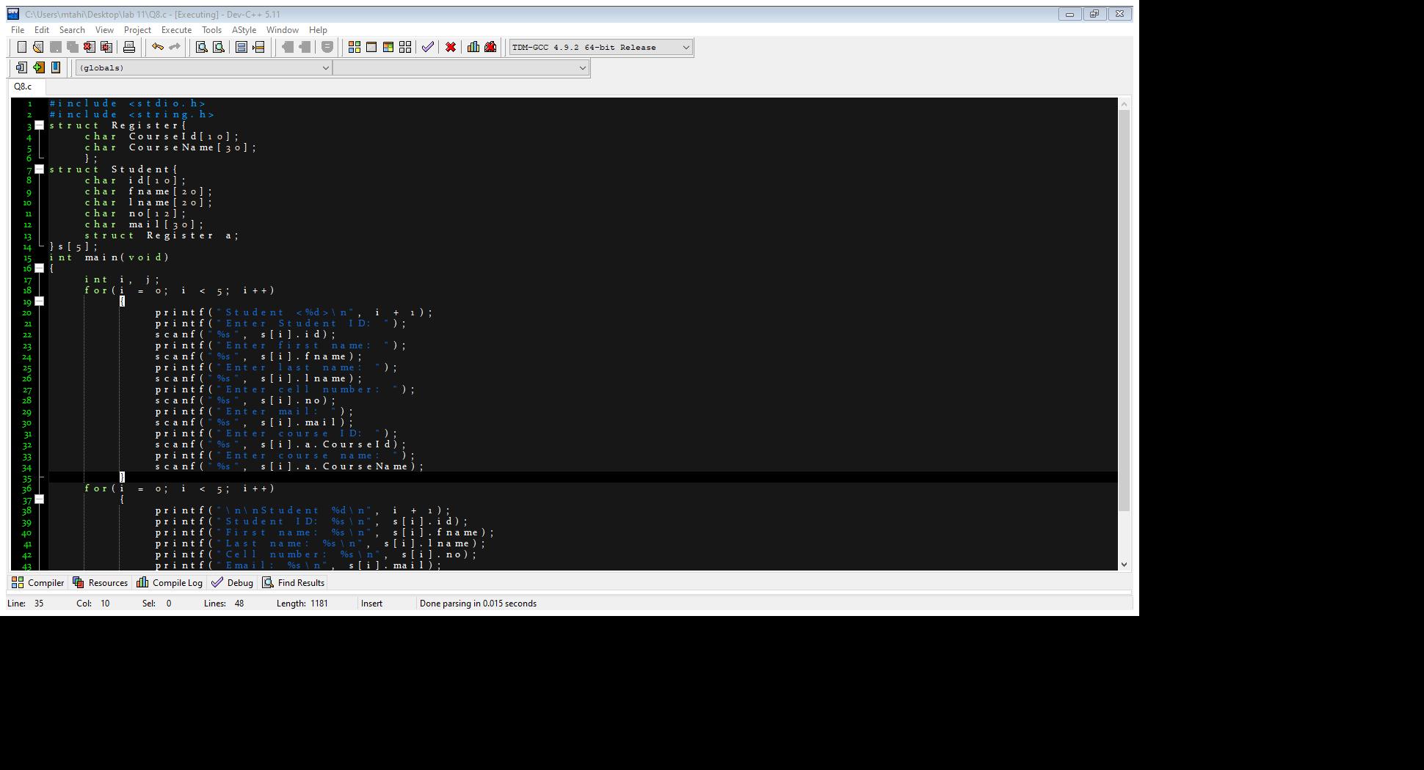

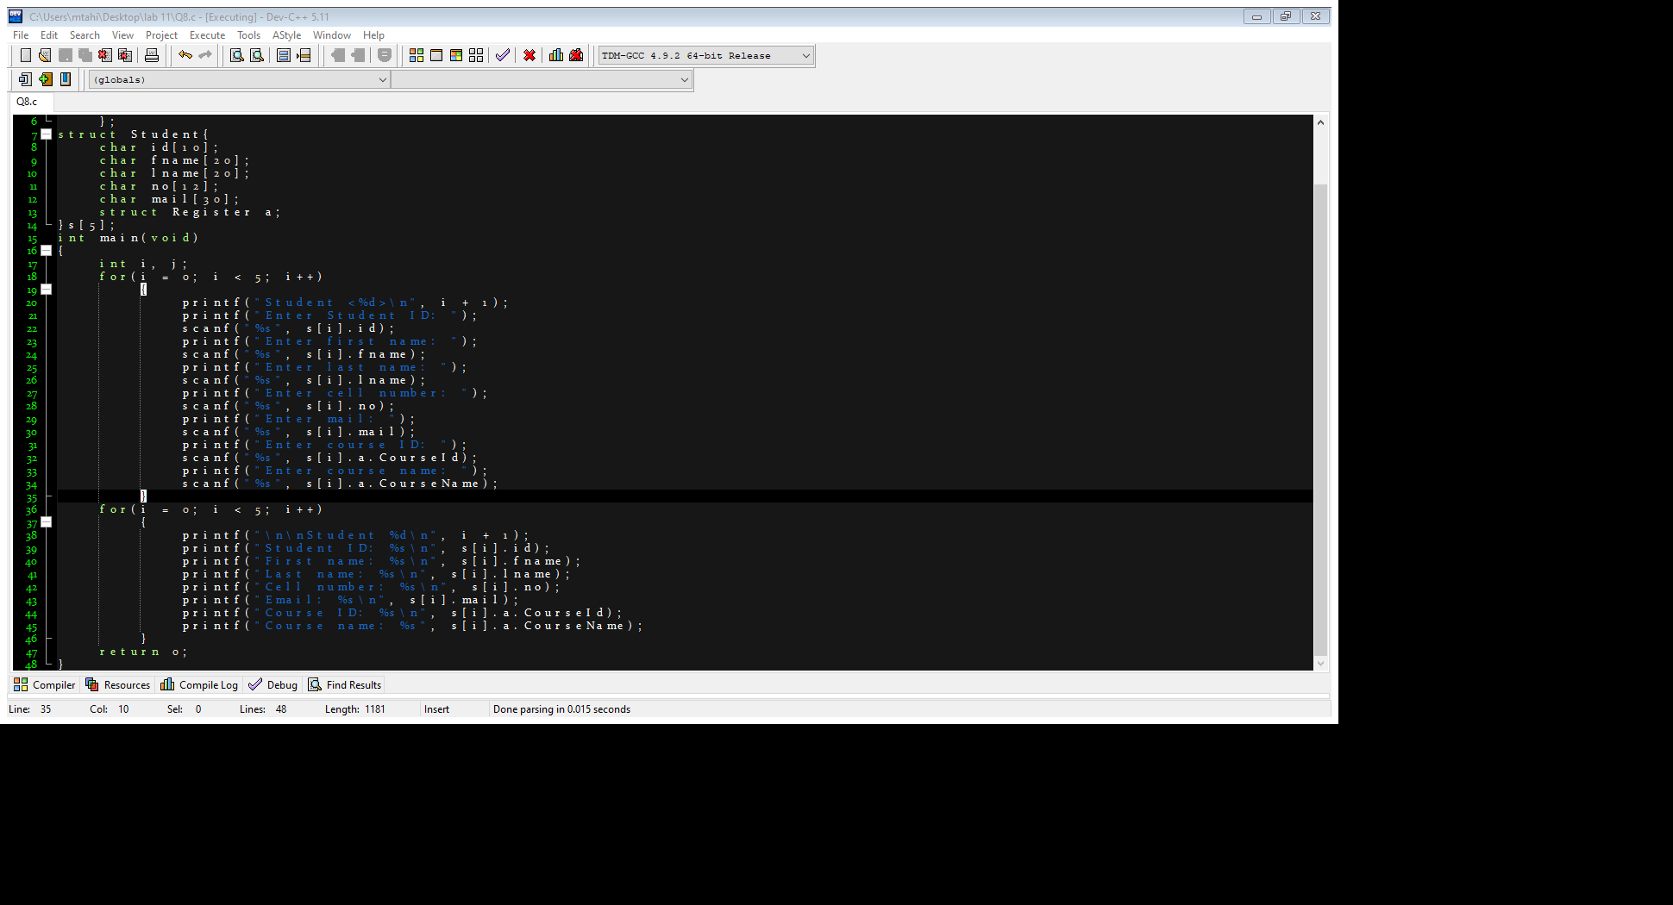

OUTPUT:

NOTE: Attached Screen Shot is of only ORGANIZED DATA

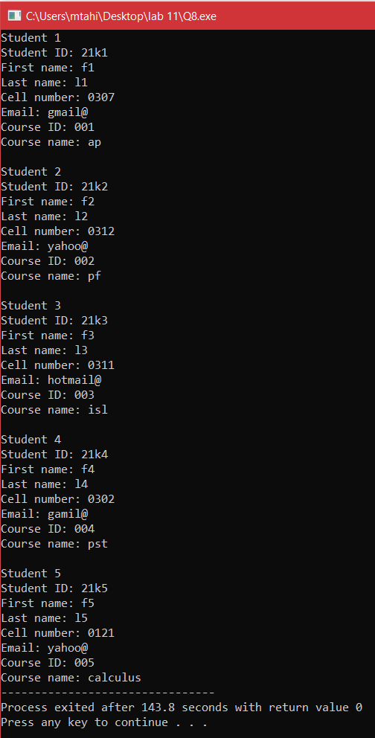

**QUESTION#9**

Write a program that asks the user to enter the total 'N' no of  
characters in the user's name {First Name + Last Name} to create a dynamic array of  
characters. After creating a dynamic array of that 'N' no of characters using  
malloc or calloc function. Finally copy your full name in it that has already  
been taken from the user before  
  
Dynamic Array = "Muhib Ahmed";

CODE:

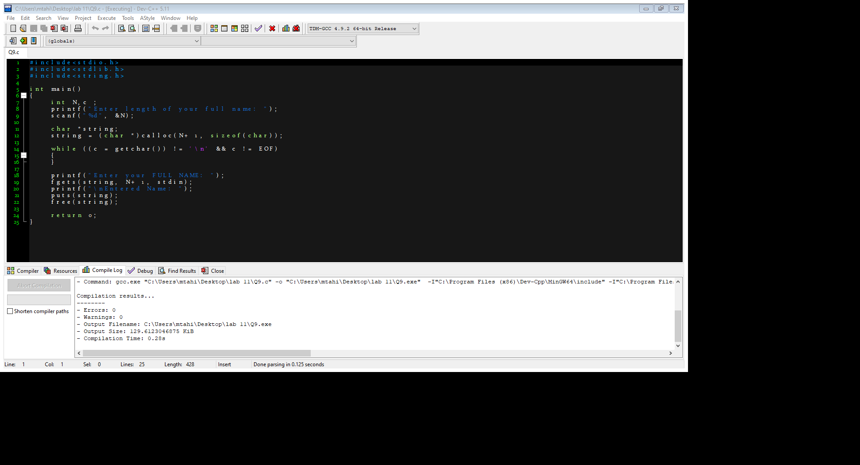

OUTPUT:

**QUESTION#10**

Using Qus. 9, resize that dynamic array of characters and append the  
array with your studentId. That student id must be taken input from the user.

CODE:

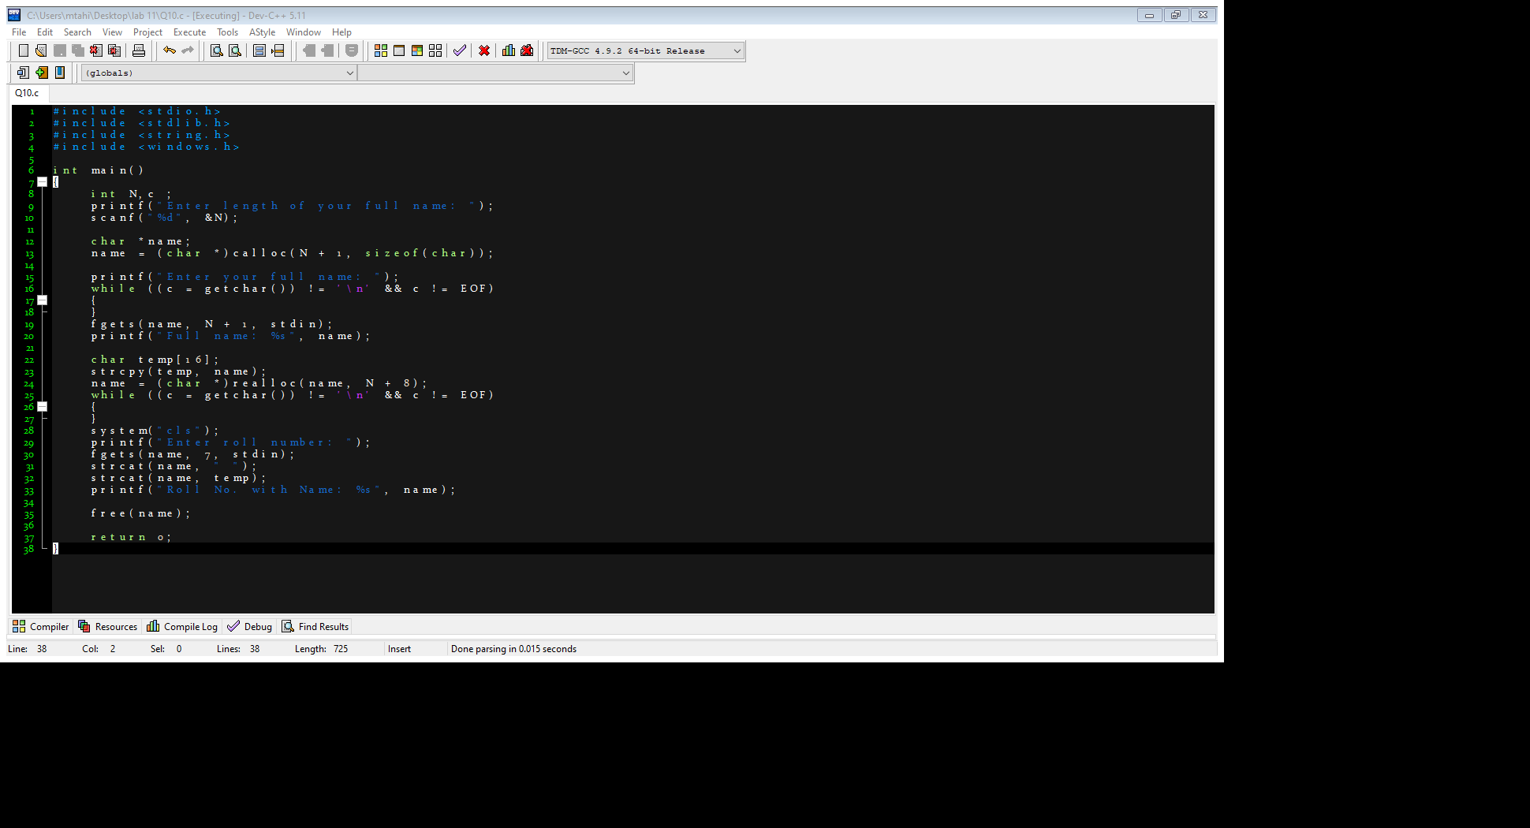

OUTPUT:

NOTE:

Attached Screen Shot is after executing CLEAR SCREEN command

